Chin Yun Ten – Poland Internship
In March 2025, I flew all the way to Gdańsk, Poland to do my Undergraduate Research II. Upon arrival, I was greeted by Prof. Tomasz Paterek’s warm welcome and his statement of “It’s a warm day today!” when it’s like 9°C outside.
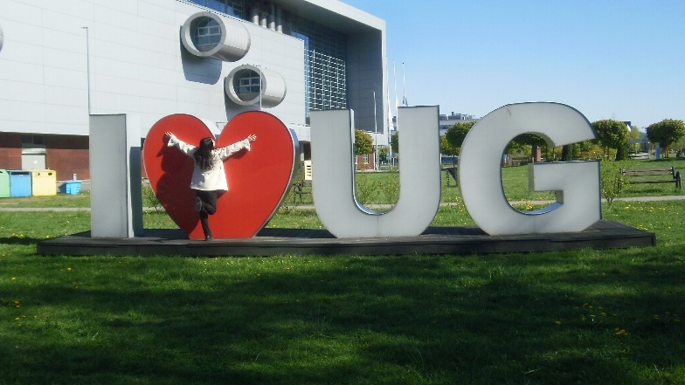
I work with Prof. Thomas Zlosnik (Prof. Tom) in the Institute of Theoretical Physics and Astrophysics of the University of Gdańsk. We are working on the “Cosmological Consequences of an Extension to General Relativity”. Prof. Tom and fellow researchers had proposed a gravitational Model B, an extension to Einstein’s theory of General Relativity, where gravity has “no degrees of freedom”. We investigate the probability that our universe can be described by Model B in its early phase, and eventually underwent inflation to arrive at its current state. To develop a path to gravitation, we used parametrized field theory to construct an action, and then analyze the equations of motion. We have obtained new solutions and we compare them to General Relativity for insights and further studies.
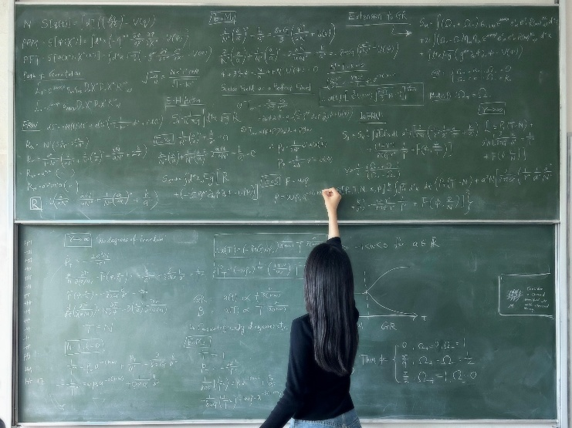
My research, summarized.
I have a lot of freedom here to work at my own pace. Almost every weekday, I will go to Office 366 – we call it the “PhD incubator” – to do my work. I’ll start with anything I feel like at the moment and progress from there. Mostly I start with mental preparation. To discuss on research progress, we’d arrange meetings with Prof. Tom. We always have a pleasant time talking, whether it’s about physics, or life.
To give a spark of glitter and magic to the working environment, I started drawing bunnies on the whiteboard. Surprisingly, it drew people together – everyone was having so much fun with the bunnies! Friends would pay attention to any new bunny, and add their own remarks. It even brought in people from other faculties to leave their bunny on the board. This was definitely one of the most wholesome things to happen during my research period.
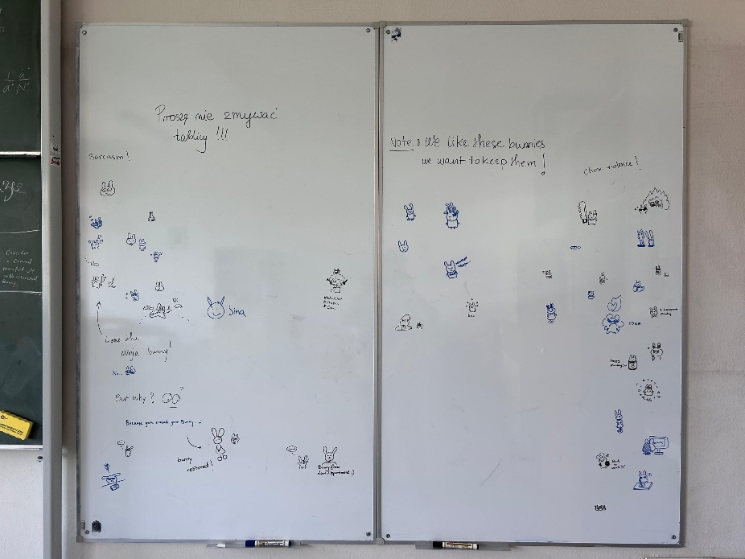
The bunny board in Office 366.
To me, aside from the amazing research environment, Poland is genuinely a very nice place to live in. I mostly walk – they have nice pedestrian streets, and it always felt so refreshing to have a nice walk to the office before working, or after meals, or to anywhere. I’ve picked up the habit of walking when the destination isn’t too far away. I also take public transport quite often. To travel to further places, I take the trams, trains and buses. They are very convenient and I very much enjoyed using these public transport.
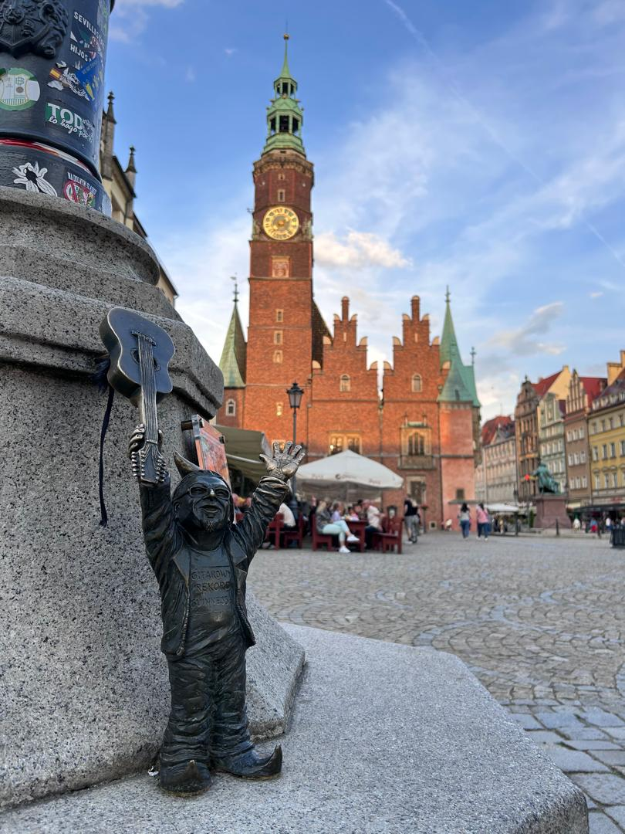
Aside from Gdańsk where my research is based in, I visited other cities as well, including Sopot, Gdynia, Toruń, Warsaw, Kraków and Wrocław. I went to the old towns, museums, parks, forests, mines, castles, towers, riverbanks, beaches, and grocery stores (this is very important). Among the places I’ve visited, my favourite is undoubtedly the Słowiński National Park. I had never felt so close to nature, sinking my feet (my whole body actually) into the fine, grain-like sand of the moving sand dunes along the Baltic coast; running over the shiny, delicate pebbles along the beach; and jumping into the crystal-clear sea (and freezing, Poland is cold!). Although we did miss the last buggy car and ran 8km non-stop out of the forest to catch the train, it was one of my fondest memories in Poland.
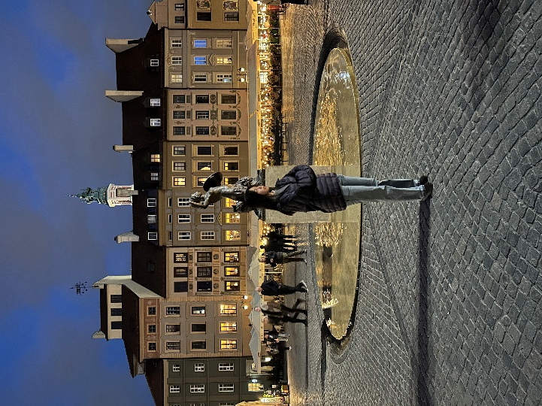
In Warsaw, the capital of Poland. Gnome hunting in Wrocław, it’s a lot of fun!
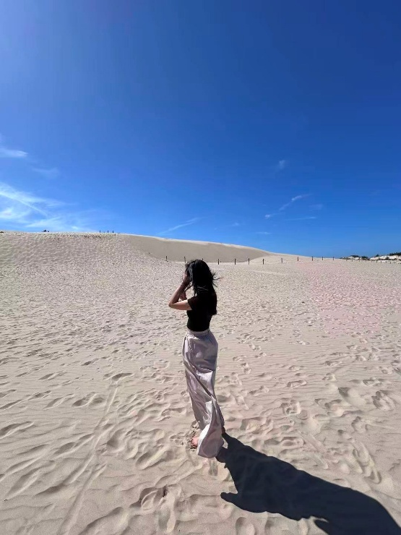
The sand dunes of Słowiński National Park.
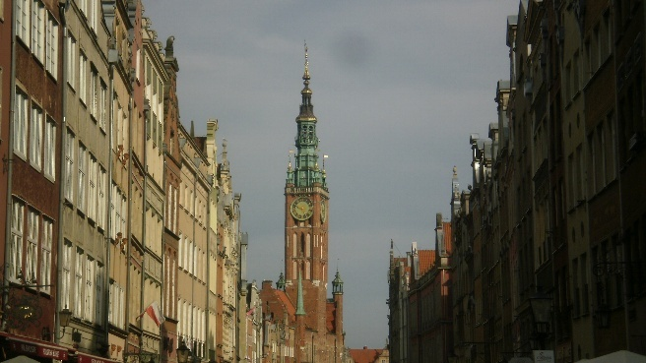
I would describe my experience in Poland as “feeling very alive”. I had experienced the arrival of spring and the blooming of flowers. Wandered in the woods, taking unknown paths and discovering breathtaking sceneries. Ran to the convenience store wearing slippers at 4°C to get tomato sauce (terrible decision, would not recommend). Walked backwards on the pedestrian street to avoid the howling wind. Cooked pasta (on a daily basis, I’m a pro now). Gathered with friends for a board game night every week. Ran into unexpected snow. Roamed around the city after dinner, watching the sun slowly set (the sunset is usually at 9pm!). Even found my favourite go-to thrifting store. Every moment, I cherish deeply in my heart. 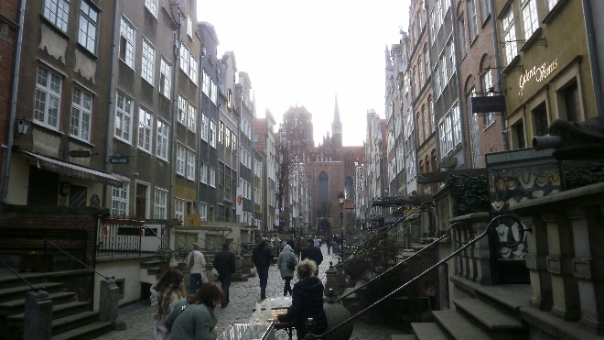
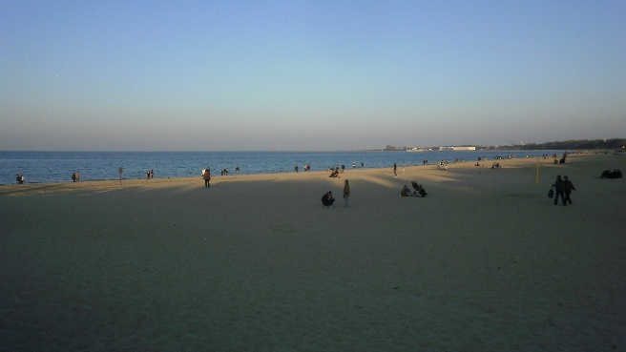
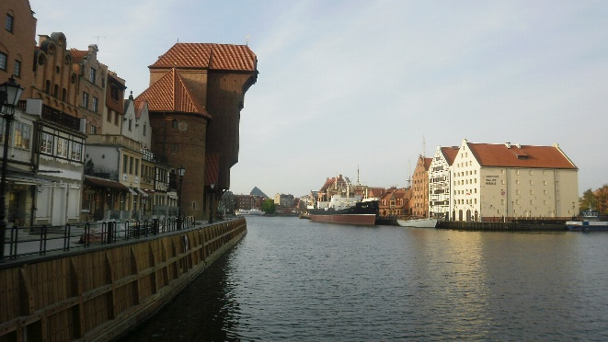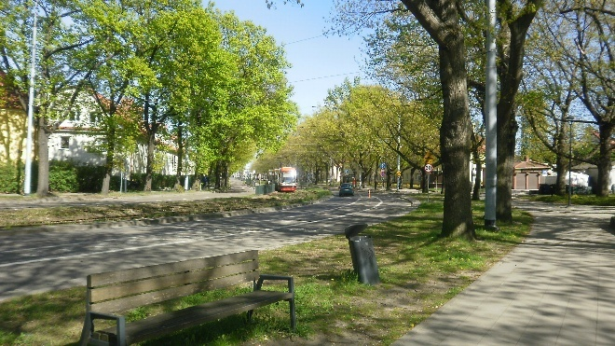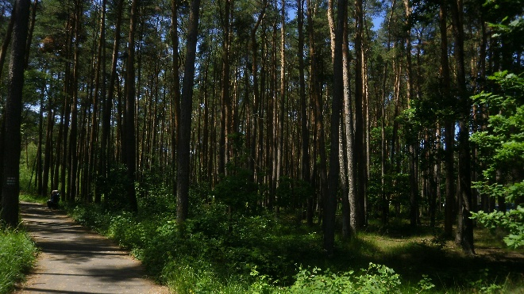
Beautiful sceneries I’d love to share.
July has arrived; the flowers are fading and the surroundings are becoming very lush and green. Summer is here but it’s time for me to leave. Carrying all the precious memories and kindness I’ve received from the amazing people I met, I’m returning home with a contented heart!
Before ending, I want to express my heartfelt gratitude to my family for their unwavering support; Prof. Tomasz and the XMUM Physics faculty for helping me gain this opportunity; Gosia, for providing so much help and guidance in preparing the visit; Prof. Tom, for being such an amazing mentor; Yu Xuan, for all the advice and help especially lending me your Wise card because I left my whole wallet in Malaysia; Mehra, for bringing so much joy as a wonderful companion and friend; and Thurston, for standing by me through everything.

